|  |
| --- |
| **STUDENT NAME** |
| Alley Chaggar |

**LAB #3**

ACTIVITY 1 2

ACTIVITY 2 8

ACTIVITY 3 12

ACTIVITY 4 14

ACTIVITY 5 16

# ACTIVITY 1

## GIMP OVERVIEW – COLORS – BASIC LAYERS – TEXT - MOVE

GIMP is a free, drawing and image editing application. This activity demonstrates how create a simple image with GIMP, set the basic settings and export it under an image format.

Follow the steps below:

1. Double – click on the GIMP shortcut on your desktop.
2. Click File 🡪 New…
3. Set the options as shown below (expand the Advanced Options):  
   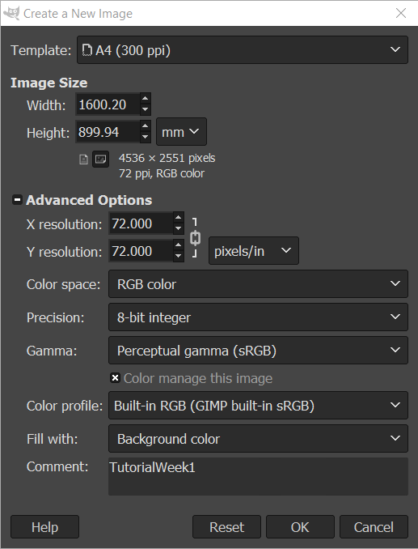
4. Click on the Bucket button under the Tools menu.  
     
   
5. Click on Foreground color icon.  
     
   
6. Select this color (approximately).  
     
   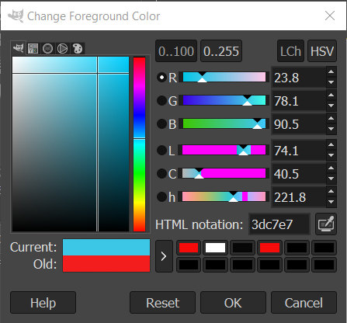
7. Click OK.
8. Click on the white Image area.
9. At the bottom – right corner click on the **Create new Layer and Add it to the Image** button.
10. Set the options as shown below:  
      
    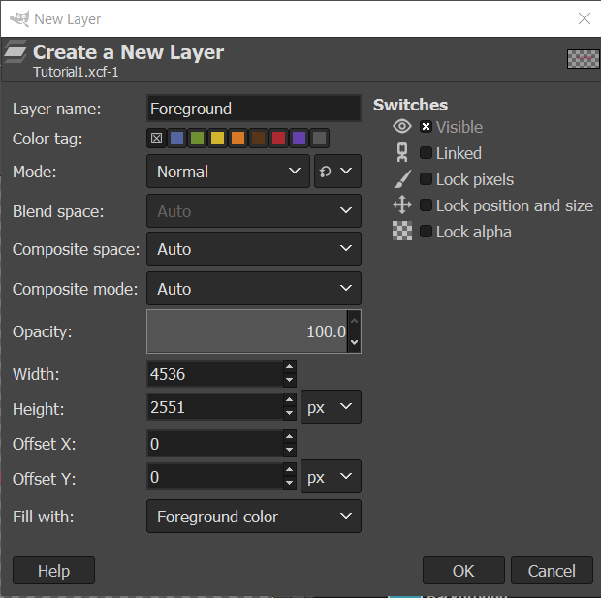
11. Click OK.
12. Click on the Bucket tool, select a yellow color.
13. Click on the Image area over the Foreground layer.

Once you complete the previous steps:

|  |
| --- |
| **TASK 1.1:**  Take a screenshot and paste it below: |
|  |

1. Click on the Text button under the Tools menu.
2. Under the settings set the color to red (approximately).
3. Set the size to 400.
4. Draw a rectangle in the middle of the image.
5. Type CLICK ME! Inside the rectangle.
6. Select the text, clicking, holding and dragging.
7. Set the size to 450 and press Enter.  
     
   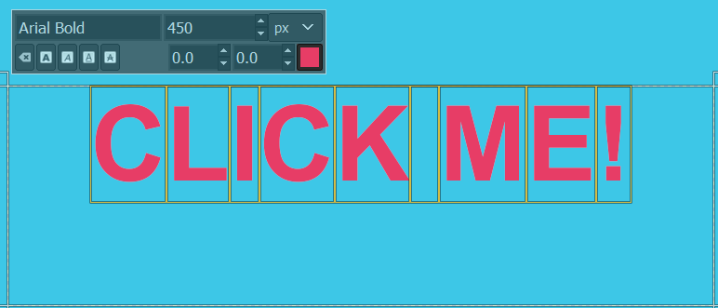
8. Use the text box handles and position the text in the middle of the image.
9. Under the Tools, select the Ellipse button.
10. Draw a circle around the text.
11. Click on the Bucket tool and pick the Black color.
12. Click inside the Ellipse area.
13. Click on the Eye button next to the Foreground Layer and hide it.
14. Click on the Background layer.
15. Click Select 🡪 None.
16. Click on the Gradient tool under the Tools.
17. Make sure that the FG to BG is selected.
18. Click at the left side of the image and drag toward the right side.
19. Click File 🡪 Save as…
20. Type the name Tutorial1.xcf.
21. Click File 🡪 Export as…
22. Navigate to a folder.
23. Expand the Select File Type tab.
24. Select the PNG image option.
25. Name the image Tutorial1.png.
26. In the next screen click Export.

Once you complete the previous steps:

|  |
| --- |
| **TASK 1.2:**  Locate the Tutorial1.png file and add it to the submission folder. |
| upload iconIn the LMS, add the file to the assignment Lab #3 submission folder. You can submit multiple files at a time. |

# ACTIVITY 2

## BASIC TRANSFORMATIONS

Transformations are the changes on object’s coordinates based on transformations matrices. This tutorial demonstrates how to apply the Move, Rotate, Scale, Shear and Perspective transformations on an object in GIMP.

Follow the steps below:

1. Click File 🡪 New…
2. Set the dimensions to 1600x1000 and press OK.
3. Under the tools select the rectangle tool and draw a rectangle in the middle of the image.
4. Click on the active foreground color button and pick any color.

|  |
| --- |
| **TASK 2.1:**  Take a screenshot of GIMP image and paste it below: |
|  |

1. Click Tools 🡪 Transform Tools 🡪 Move.
2. Click on the object, hold the button and move the shape toward the bottom of the image.
3. Click Tools 🡪 Transform Tools 🡪 Rotate.
4. Click on the object.
5. In the Rotate menu set the rotation to 5 and press Rotate.
6. Click Tools 🡪 Transform Tools 🡪 Scale.
7. Set the Width to 1000 and the Height to 450 and press Scale.
8. Click Tools 🡪 Transform Tools 🡪 Rotate.
9. In the Rotate menu set the rotation to **-5** and press Rotate.
10. Click Tools 🡪 Transform Tools 🡪 Shear.
11. Set the Shear Magnitude Width to 300 and Heigth to -100.
12. Click Tools 🡪 Transform Tools 🡪 Perspective.
13. Hold and drag the top left corner toward the left-end of the image.

Once you complete the previous steps:

|  |
| --- |
| **TASK 2.2:**  Take a screenshot of GIMP image and paste it below: |
|    * I also decided to do object even though it said to do image, but it also says invalid |

# ACTIVITY 3

## SELECTION TOOLS

The selection tools allow us to select areas after selectin paths. The path can be of Rectangular or Elliptical shape or may have special features. This activity demonstrates how to crop part of an image and combine it with another.

Follow the steps below:

1. Download the Earth and the Jupiter image from E-Centennial.
2. Click File 🡪 New…
3. Set the dimensions to 1200 and 900 and press OK.
4. Click File 🡪 Open as Layers…
5. Select the Earth.jpg image.
6. Click File 🡪 Open as Layers.
7. Select the Jupiter.jpg image.
8. Bring the Earth layer to the top of the layers.
9. Click on the Ellipse selection tool and select the Earth’s outline, excluding the space.
10. Click Edit 🡪 Cut.
11. Edit 🡪 Paste.
12. At the new layer right click 🡪 To New Layer.
13. Name the new layer EarthTemp.
14. Delete the previous Earth layer.
15. Click on the Fuzzy select tool.
16. Select all the see areas and click Delete.
17. Select all the Cloud-covered areas and delete them too.
18. Select the EarthTemp Layer
19. Click on the Free Select tool and pick only the ground area.
20. Click Select 🡪 Invert.
21. Press Delete.
22. Click on the Scale tool (select the earth if needed).
23. Reduce the Earth’s size.
24. Click on the Move button and move the earth over Jupiter’s “eye”.
25. Export the image as png (see Activity 1) and name it EarthOnJupiter.

|  |
| --- |
| **TASK 3.1:**  Take a screenshot of GIMP image and paste it below: |
|  |

|  |
| --- |
| **TASK 3.2:**  Locate the EarthOnJupiter.png file and add it to the submission folder. |
| upload iconIn the LMS, add the file to the assignment Lab #3 submission folder. You can submit multiple files at a time. |

# ACTIVITY 4

## ALPHA CHANNEL AND TRANSPARENCY

The selection tools allow us to select areas after selectin paths. The path can be of Rectangular or Elliptical shape or may have special features. This activity demonstrates how to crop part of an image and combine it with another.

Follow the steps below:

1. Download the images Flower.jpg and Buttergly.jpg, from E-  
   Centennial and store them to your computer.
2. Keep using GIMP.
3. File 🡪 Open 🡪 Select the Flower Image.
4. File 🡪 Open as Layers 🡪 Select the Butterfly image.  
     
   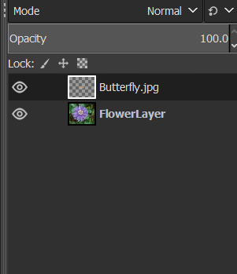
5. Make sure the Butterfly layer is at the top.
6. Click on the Butterfly layer.
7. Select Layer 🡪 Transparency 🡪 Add Alpha Channel.
8. Click any selection tool, you consider more appropriate and select the butterfly’s outline.
9. Click Select 🡪 Inverse.
10. Click Edit 🡪 Clear.
11. Copy the Butterfly and place at least 4 over the flower.
12. Use move, scale and rotate the butterflies to match the size of the flower.
13. Export the image as BugOnFlower.png.

|  |
| --- |
| **TASK 4.1:**  Take a screenshot of GIMP image and paste it below: |
|  |

|  |
| --- |
| **TASK 4.2:**  Locate the BugOnFlower.png file and add it to the submission folder. |
| upload iconIn the LMS, add the file to the assignment Lab #3 submission folder. You can submit multiple files at a time. |

# ACTIVITY 5

## EFFECTS

GIMP supports sets of algorithms applied to the image pixels changing their look. These sets of algorithms are called Effects. This activity demonstrates some of these effects.

Follow the steps below:

1. Download the image Face.jpg from E-Centennial and store it to your computer.
2. Drag and drop the image into the GIMP main window.
3. If asked to rotate click Rotate.
4. Click Filters 🡪 Décor 🡪 Coffee Stains.
5. Set the Stains to 4.
6. Click Filters 🡪 Décor 🡪 Old Photo.
7. In the next screen click OK.
8. Click Filters 🡪 Décor 🡪 Round Corners.
9. Set the Edge Radius to 30 and the Blur Radius to 20.
10. Click Filters 🡪 Blur 🡪 Zoom Motion Blur.

Once you complete the previous steps:

|  |
| --- |
| **TASK 5.1:**  Take a screenshot of GIMP image and paste it below: |
|  |

1. Click Filters 🡪 Edge Detect 🡪 Edge.
2. Set the Amount to 7.4 and press OK.
3. Click Filters 🡪 Edge Detect 🡪 Neon.
4. Set the Radius to 10 and the Intensity to 1.
5. Click OK.
6. Click on the Elliptic Selection tool and select the girl’s face.
7. Click Filters 🡪 Blur 🡪 Pixelize.
8. Set the Block width and height to 200.
9. Press OK.
10. Export the image as Face.png

Once you complete the previous steps:

|  |
| --- |
| **TASK 5.2:**  Take a screenshot of GIMP image and paste it below: |
|  |

|  |
| --- |
| **TASK 5.3:**  Locate the Face.png file and add it to the submission folder. |
| upload iconIn the LMS, add the file to the assignment Lab #3 submission folder. You can submit multiple files at a time. |

FINAL STEP: Save this document as a PDF. Upload the PDF to the Lab #3 submission folder.